

Whether your financial goals are maximizing growth opportunities, tax efficiency or accelerating wealth, consider a TFSA Loan as part of the solution.

No matter what life stage you're in, a TFSA loan can assist with your savings goals and ensure you’re using the benefits of a TFSA to the fullest.

What saver type are you?

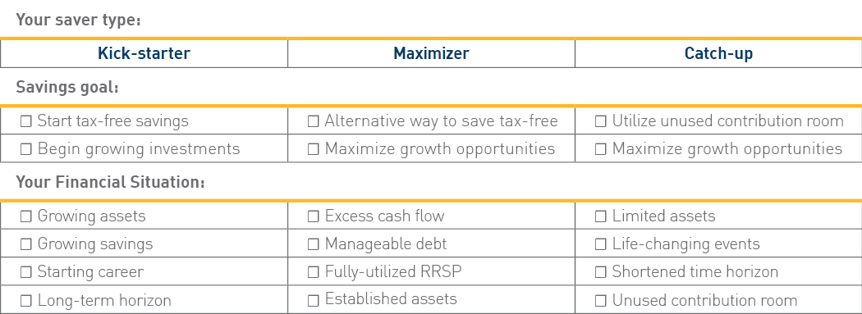

To find out how a TFSA loan can help fund your TFSA to amplify savings, visit b2bbank.com/talktfsa for case studies and client resources.

Let’s talk about how a TFSA loan can help you utilize the tax-free growth of your TFSA.

Sincerely,
[ADVISOR NAME]
[ADVISOR TITLE]
[ADVISOR COMPANY]
[ADVISOR TELEPHONE]
[ADVISOR CELLULAR]
[ADVISOR E-MAIL]
[OTHER]
[OTHER]

B2B Bank is not affiliated with the financial advisor, company or any dealer mentioned herein and does not provide investment advice to individuals or advisors and does not endorse nor promote any investment products. The dealer and advisor, not B2B Bank, are responsible for determining the suitability of investments for their clients and for informing them of the risks associated with borrowing to invest. While TFSA loans have the ability to magnify gains, they also have the potential to magnify market losses. B2B Bank acts solely in the capacity of lender and loan account administrator. Any loan approval by B2B Bank should not be construed as an endorsement of any investment choice, program or strategy. All loans are subject to credit approval and borrowed monies are due and payable regardless of the performance of the investments purchased. B2B Bank reserves the right to request additional information or documentation at its sole discretion. The B2B Bank TFSA Loan Program is available exclusively through licensed financial advisors.

